**FedEx Ground is Now Hiring -**

**Meet us at our Virtual Job Fair!**

***Wednesday, November 17, 1:00 pm***

***Click on this link to Register:*** <https://www.eventbrite.com/e/195513986597>

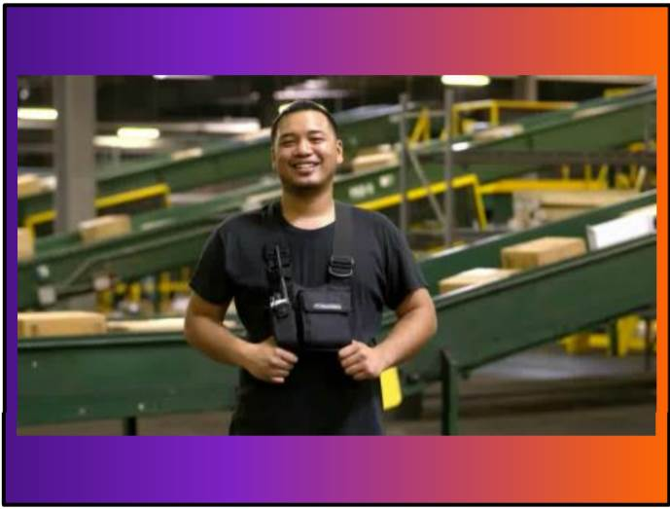**Join our team and make an impact**

FedEx is hiring – from Package Handlers to Operations Managers, there’s something for everyone on our team. Come find out what’s best for you.

**Full- and Part-time Positions Available**

* **Operation Managers**
* **Package Handlers**
* **Operation Administrators**

**Benefits:**

* Rapid Career Advancement
* Attendance Bonus for Package Handlers
* Medical, Dental, Vision insurance
* $5250.00 in educational assistance per year
* Employee Discount program

**Locations:**

**Wheeling 1 – 1430 S. Wolf Rd. Wheeling, IL 60090**

**Wheeling 2 – 1234 Peterson Dr. Wheeling, IL 60090**

**Wheeling 3 - 960 S. Wolf Rd. Wheeling, IL 60090**

**Niles – 5959 W. Howard St., Niles, IL 60714**

**Grayslake – 1260 Rowena Rd. Grayslake, IL 60030**

**How to apply:**

1. **PACKAGE HANDLERS - Text FXGjobs to 33011 or go to groundwarehousejobs.fedex.com**
2. **OPERATION MANAGERS - Text GroundManager to 33011 or go to groundcareers.fedex.com.**
3. **OPERATION ADMINISTRATORS - go to groundcareers.fedex.com**