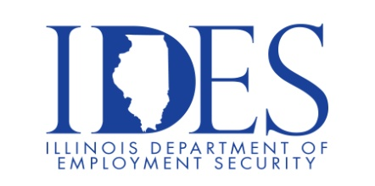

You are invited to attend the
EATON Corporation B-Line
Powering Business Worldwide
Hiring Event for Troy & Highland locations
*hiring for multiple manufacturing positions

What: Eaton Corp. Hiring Event (for Troy & Highland, IL locations)
When: January 12, 2022, 9:00 am – 3:00 pm
Where: Best Western Premier Hotel, 3559 College Ave., Alton, IL 62002

This event is sponsored by IDES and Eaton Corporation.

Make Sure Your Resume is on Illinoisjoblink.com
Illinois businesses are hiring. And they are looking for workers on Illinoisjoblink.com The state’s hiring board features more than 100,000 help-wanted ads. Job seekers can build multiple resumes to emphasize different skills and experiences. Business owners can use keyword matching technology to search resumes and find the best candidate. Illinoisjoblink.com is free for workers and employers. It compares favorably to private efforts that cost hundreds of dollars. No-cost HR recruitment services are available at the website and at (877) 342-7533.



Find a Job/Find an Employee

