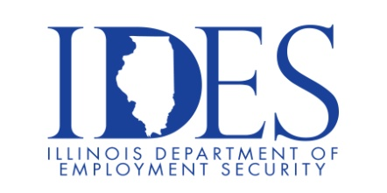

You are invited to a Job Fair!

What: Job Fair
When: March 13, 2022 9 a.m. to 5:00 p.m.
Where: CEMI Mine Repair
CEMI Centralia Mine Repair Shop
2400 Wabash Ave
Centralia, IL 62801

This event is sponsored by IDES and CEMI.

Make Sure Your Resume is on Illinoisjoblink.com
Illinois businesses are hiring. And they are looking for workers on Illinoisjoblink.com The state’s hiring board features more than 100,000 help-wanted ads. Job seekers can build multiple resumes to emphasize different skills and experiences. Business owners can use keyword matching technology to search resumes and find the best candidate. Illinoisjoblink.com is free for workers and employers. It compares favorably to private efforts that cost hundreds of dollars. No-cost HR recruitment services are available at the website and at (877) 342-7533.



Find a Job/Find an Employee

