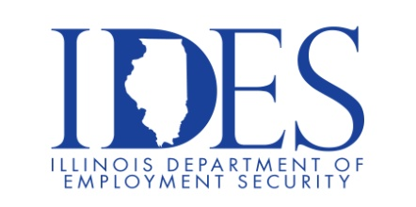

You are invited to the Marion VA Health Care System Hiring Fair!

What: Health Care Hiring Fair
When: Saturday April 1, 2023 10 AM – 3 PM
Where: Center for Behavioral Health Building
2401 W. Main St., Marion Il. 62959

They are hiring:

RN’s
LPN’s
Nursing Assistants
Medical Technologists
Pharmacists

This event is sponsored by The Dept. of Veterans Affairs.

Make Sure Your Resume is on Illinoisjoblink.com
Illinois businesses are hiring. And they are looking for workers on Illinoisjoblink.com The state’s hiring board features more than 100,000 help-wanted ads. Job seekers can build multiple resumes to emphasize different skills and experiences. Business owners can use keyword matching technology to search resumes and find the best candidate. Illinoisjoblink.com is free for workers and employers. It compares favorably to private efforts that cost hundreds of dollars. No-cost HR recruitment services are available at the website and at (877) 342-7533.



Find a Job/Find an Employee

