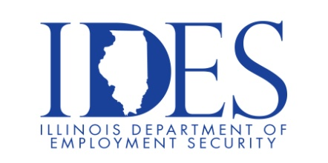

You are invited to the Illinois Department of Central Management Services Application Process Workshop

Central Management Services will highlight careers and the benefits of working for the State, breakdown the application process, and answer all questions regarding the hiring process.

What: Illinois Department of Central Management Services Application Process Workshop
When: Tuesday, April 4th 2023 Begins Promptly at 10:00 am
Where: Man-Tra-Con
3117 Civic Circle Blvd. Suite B
Marion, IL

The State of Illinois has fulfilling career opportunities in a variety of public service sectors, including but not limited to: Public Safety, Human Services, Healthcare, Public Health, Natural Resources, Professional Regulation, Business Development and many more. The State of Illinois offers career growth potential regardless of your chosen career path.

This event is sponsored by the Illinois Department of Central Management Services and the
Illinois Department of Employment Security

Make Sure Your Resume is on Illinoisjoblink.com
Illinois businesses are hiring. And they are looking for workers on Illinoisjoblink.com The state’s hiring board features more than 100,000 help-wanted ads. Job seekers can build multiple resumes to emphasize different skills and experiences. Business owners can use keyword matching technology to search resumes and find the best candidate. Illinoisjoblink.com is free for workers and employers. It compares favorably to private efforts that cost hundreds of dollars. No-cost HR recruitment services are available at the website and at (877) 342-7533.



Find a Job/Find an Employee

