

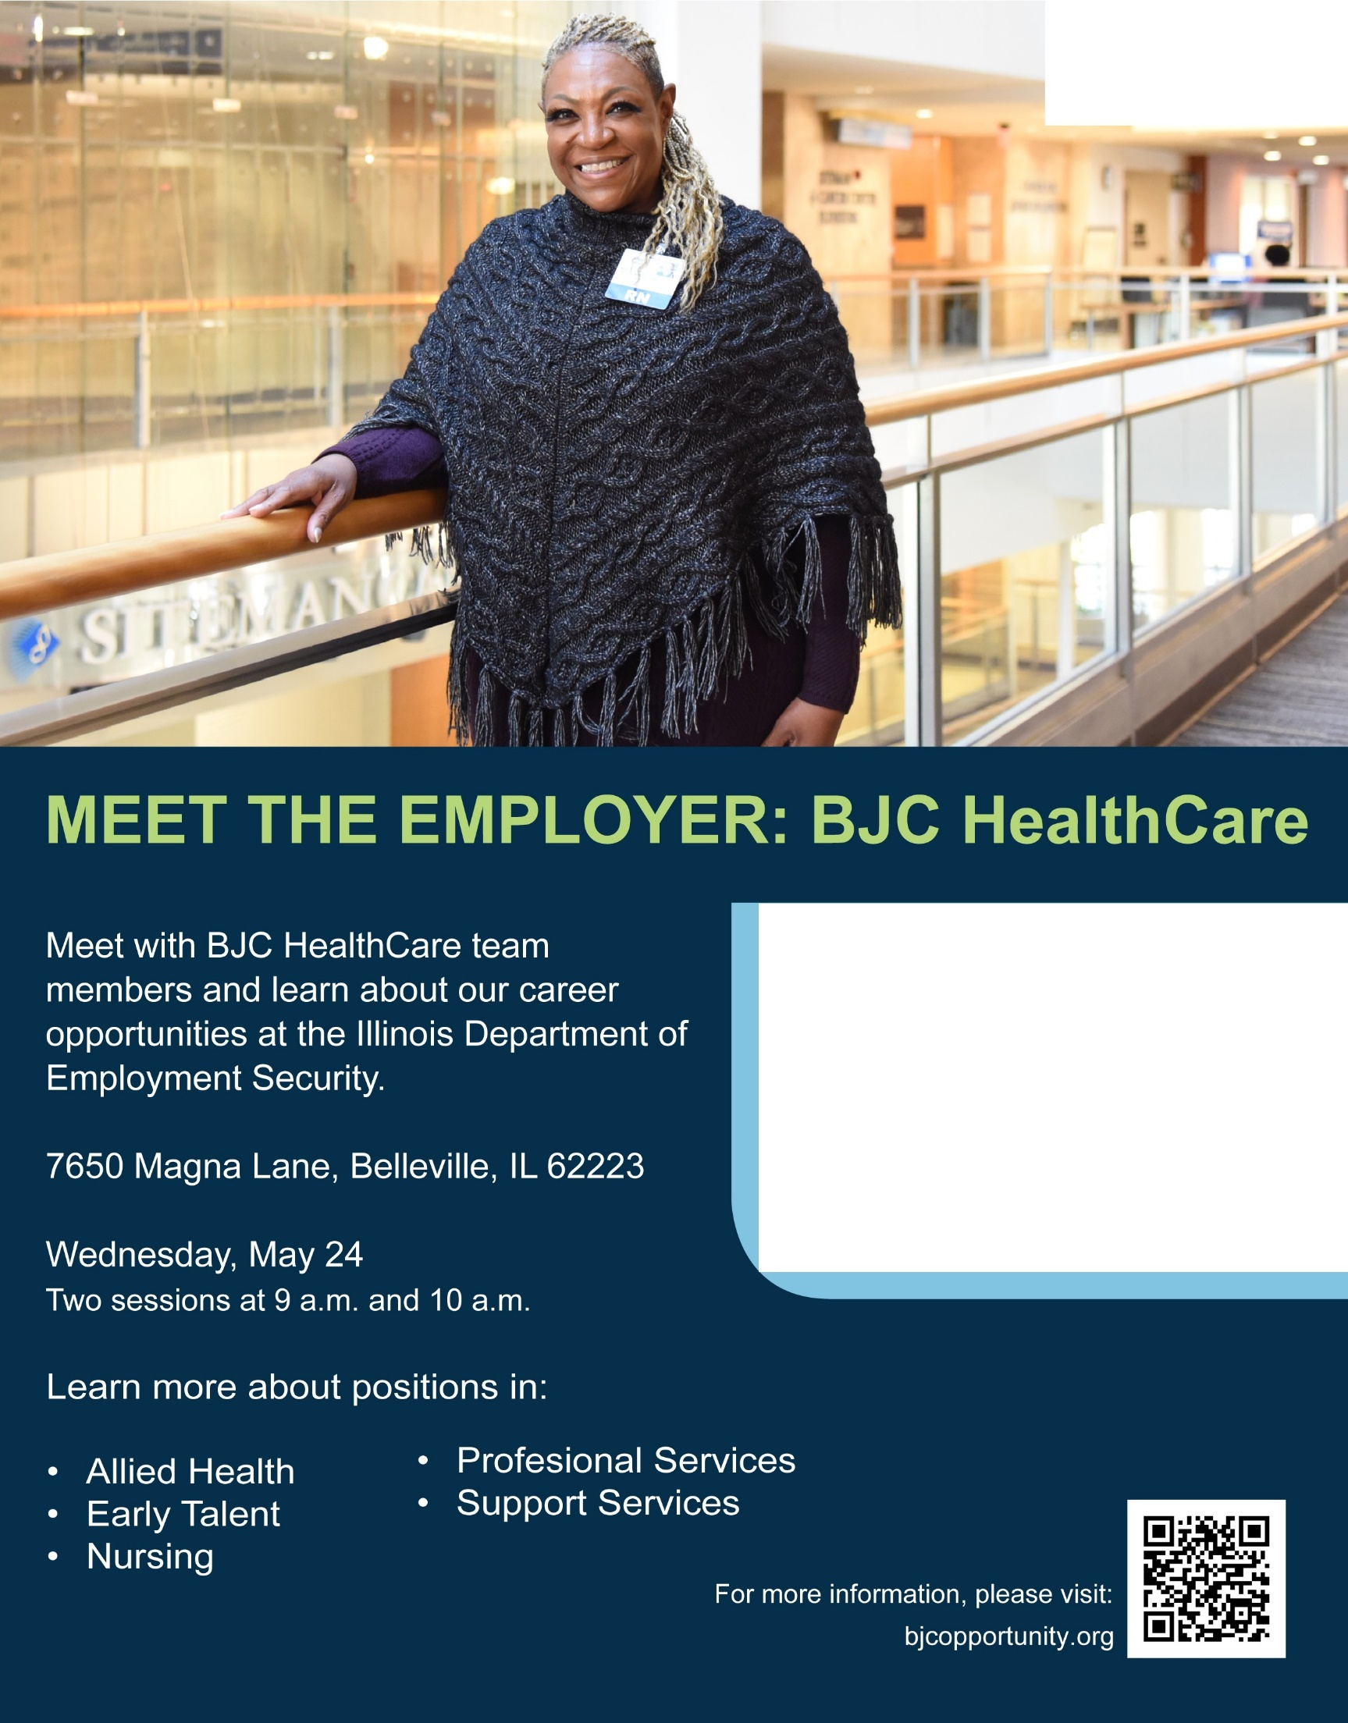

**mm r-r-** -

**The World's Best Medicine Begins With You.**

About BJC HealthCare

BJC HealthCare is one of the largest nonprofit health care organizations in the United States, and is focused on delivering services to residents primarily in the greater St. Louis and southern Illinois regions.

Benefits include tuition reimbursement, career advancement, paid time off, 401(k), pension plan*, life insurance, medical/dental/vision, and more.

*Pension plan does not apply to all BJC locations.