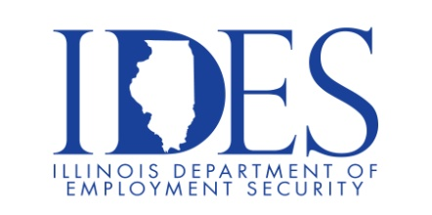
Want to work for the State of Illinois!

Don’t know where to start?

This State of Illinois Applicant Workshop is for you!

What: State of Illinois Applicant Workshop
When: Wednesday, June 7th, 2023, 10:00 am – 1:00 pm
Where: Southeastern Illinois College
1700 College Avenue
Carmi, IL

The State of Illinois is seeking candidates to fill multiple positions in multiple agencies. This Applicant Workshop event focuses on employment opportunities,
application criteria and hiring procedures.

Business leaders want to know why they should hire you.
How will you make their company more successful?

Make Sure Your Resume is on Illinoisjoblink.com
Illinois businesses are hiring. And they are looking for workers on Illinoisjoblink.com The state’s hiring board features more than 100,000 help-wanted ads. Job seekers can build multiple resumes to emphasize different skills and experiences. Business owners can use keyword matching technology to search resumes and find the best candidate. Illinoisjoblink.com is free for workers and employers. It compares favorably to private efforts that cost hundreds of dollars. No-cost HR recruitment services are available at the website and at (877) 342-7533.

Find a Job/Find an Employee

