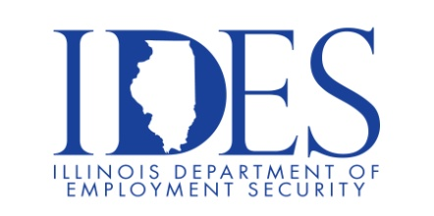

U. S. Department of Veterans Affairs
Veteran Readiness and Employment Presents…
HYBRID CAREER FAIR
VETERANS • SERVICE MEMBERS • M I L I TARY SPOUSES

What: Hybrid Career Fair
When: Wednesday June 7, 2023 11 AM – 3 PM
Where: VIRTUAL CAREER FAIR

VIRTUAL CAREER FAIR
VR&E IN PARTNERSHIP WITH
Nationwide Virtual Career Fair and Four
In-Person Career Fairs occurring simultaneously

Register at: https://pvapi.premiervirtual.com/s/dqXBY8

This event is sponsored by The Dept. of Veterans Affairs.

Make Sure Your Resume is on Illinoisjoblink.com
Illinois businesses are hiring. And they are looking for workers on Illinoisjoblink.com The state’s hiring board features more than 100,000 help-wanted ads. Job seekers can build multiple resumes to emphasize different skills and experiences. Business owners can use keyword matching technology to search resumes and find the best candidate. Illinoisjoblink.com is free for workers and employers. It compares favorably to private efforts that cost hundreds of dollars. No-cost HR recruitment services are available at the website and at (877) 342-7533.



Find a Job/Find an Employee

