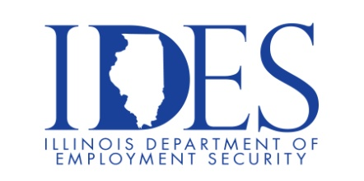

Are You Looking for a Job?

Your Illinois Department of Employment Security Invites You to the JobsNewsUSA Job Fair

What: JobsNewsUSA Job Fair
When: Thursday, July 20th, 2023 10:00am – 2:00pm
Where: Orlando’s Event and Convention Center
2050 Dorsett Village
Maryland Heights MO, 63043

Please dress for success and bring resumes. 60+ employers are expected.

- American Freedom Benefits
- Bethesda Health Group
- Clean The Uniform Company
- Club Car Wash
- Commerce Bank St. Louis
- Endoscopy Development Company
- Enterprise Fleet Management
- First Community Credit Union
- Francis Howell School District
- Friendship Village of St. Louis
- GardaWorld
- Hawthorn Children’s Psychiatric Hospital
- iHeart Media
- Inhance Technologies
- Legacy Pharma Solutions
- Massage Luxe/Xist Fitness
- McKesson Saint Louis Distribution Center
- MEMC
- Missouri Department of Social Service

Make Sure Your Resume is on Illinoisjoblink.com
Illinois businesses are hiring. And they are looking for workers on Illinoisjoblink.com The state’s hiring board features more than 100,000 help-wanted ads. Job seekers can build multiple resumes to emphasize different skills and experiences. Business owners can use keyword matching technology to search resumes and find the best candidate. Illinoisjoblink.com is free for workers and employers. It compares favorably to private efforts that cost hundreds of dollars. No-cost HR recruitment services are available at the website and at (877) 342-7533.


