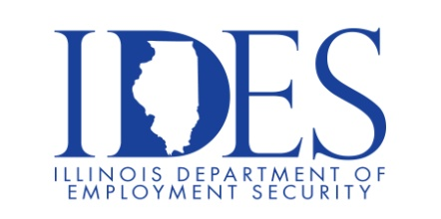

1572 JOBS AVAILABLE!!!!

Your Illinois Department of Employment Security Invites You to an Employer Hiring Event featuring BJC HealthCare

What: BJC HealthCare Hiring Events
When: Tuesday July 25th, 2023, 9:00 AM and 11:00 AM (Two Sessions)
Where: American Job Center
7650 Magna Dr Ste 120
Belleville Illinois 62223

The Illinois Department of Employment Security and BJC HealthCare invites you to a hiring event on Tuesday July 25th, 2023, 9:00 AM and 11:00 AM. (Two Sessions) BJC Health Care team members will be there. This event will be held at the America’s Job Center 7650 Magna Dr., STE 120 Belleville Illinois 62223. Please bring your work history and dress appropriately. Many positions are available at multiple locations.

- You must be registered and have an active resume in www.IllinoisJobLink.com
- Please dress to impress and be prepared to listen and learn!
- BJC HealthCare is seeking candidates to fill multiple positions at multiple locations. This hiring event provides an overview of employment opportunities, application criteria and hiring procedures.
- You will be given time to ask questions.
- LIMITED SEATING
Business leaders want to know why they should hire you.
How will you make their company more successful?

Make Sure Your Resume is on Illinoisjoblink.com
Illinois businesses are hiring. And they are looking for workers on Illinoisjoblink.com The state’s hiring board features more than 100,000 help-wanted ads. Job seekers can build multiple resumes to emphasize different skills and experiences. Business owners can use keyword matching technology to search resumes and find the best candidate. Illinoisjoblink.com is free for workers and employers. It compares favorably to private efforts that cost hundreds of dollars. No-cost HR recruitment services are available at the website and at (877) 342-7533.

Find a Job/Find an Employee

