**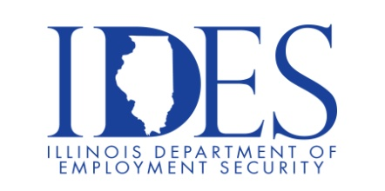  
Is proud to partner with**

**Draft Kings at Casino Queen for a Career Fair!  Wednesday, August 16th from 4pm-7pm.**

**for an On-Site Recruitment Event**

**Draft Kings at Casino Queen**

**200. S Front Street | East St. Louis, IL**

**NOW HIRING: Multiple Positions!**

**IMPERIAL HALL BALLROOM INSIDE DRAFTKINGS AT CASINO QUEEN HOTEL**

**Business Casual Attire**

* **Top Industry Pay**
* **Comprehensive health packages, including a free option for**

Full-Time Team Members

* **Paid Time Off**
* **Tuition Reimbursement**
* **401k with company match**
* **Fun Work Environment**
* **Shift Differential offered starting from 10pm to 6am**

*Interested Candidates should bring proof of

availability to work in the US and your work history.

**Make Sure Your Resume is on Illinoisjoblink.com**

Illinois businesses are hiring. And they are looking for workers on [Illinoisjoblink.com](http://www.illinoisjoblink.com/) The state’s hiring board features more than 100,000 help-wanted ads. Job seekers can build multiple resumes to emphasize different skills and experiences. Business owners can use keyword matching technology to search resumes and find the best candidate. Illinoisjoblink.com is free for workers and employers. It compares favorably to private efforts that cost hundreds of dollars. No-cost HR recruitment services are available at the website and at (877) 342-7533.

**[](https://illinoisjoblink.illinois.gov/ada/default.cfm)**

***Find a Job/Find an Employee***