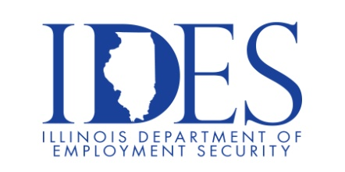

You are invited to the
Veterans Day Celebration at the DuQuoin State Fair!

What: Veterans Day at the DuQuoin State Fair
When: Sunday August 27th, 10:00 a.m. – 2:30 p.m. EST
Where: DuQuoin State Fairgrounds, 655 Executive Dr, Du Quoin, IL 62832

10:00 AM – 2:00 PM Benefits Expo
12:00 PM – 1:30 PM Veterans Lunch (Free to veterans and immediate family)
11:30 AM – 1:30 PM Cody Galloway
1:35 PM – 2:30 PM Veterans Day Program

This event is sponsored by IDES and the DuQuoin State Fair.

Make Sure Your Resume is on Illinoisjoblink.com
Illinois businesses are hiring. And they are looking for workers on Illinoisjoblink.com The state’s hiring board features more than 100,000 help-wanted ads. Job seekers can build multiple resumes to emphasize different skills and experiences. Business owners can use keyword matching technology to search resumes and find the best candidate. Illinoisjoblink.com is free for workers and employers. It compares favorably to private efforts that cost hundreds of dollars. No-cost HR recruitment services are available at the website and at (877) 342-7533.



Find a Job/Find an Employee

