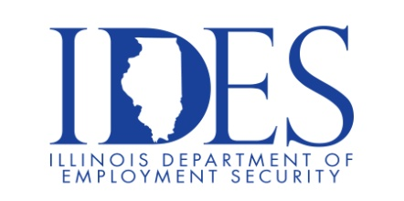

You are invited to Attend the Dyno Nobel Hiring Event

What: Dyno Nobel Hiring Event
When: Thursday, September, 21st. 2023 10:00am - 1:00pm
Where: Shawnee Community College
Anna Extension Center
1150 E. Vienna Street Room 116
Anna, IL 62906

This event is sponsored by the Illinois Department of Employment Security, Man-Tra-Con and
Dyno Nobel

Booster Department
Candidates will efficiently set-up, fill, inspect, and package all Cast Booster products. The operator will assure safe and timely processing of PETN to supply the demand of booster operations with respect to plant and site specific safety rules and quality standards.
NONEL DEPARTMENT
Candidates will safely and efficiently manufacture
a quality product by hand, and use of an automated system. The position is also responsible for properly stocking manufacturing areas and preparing product for shipping.
SALARY
$23.96 per hour to start, with a shift differential payment on the off shift.

Make Sure Your Resume is on Illinoisjoblink.com
Illinois businesses are hiring. And they are looking for workers on Illinoisjoblink.com The state’s hiring board features more than 100,000 help-wanted ads. Job seekers can build multiple resumes to emphasize different skills and experiences. Business owners can use keyword matching technology to search resumes and find the best candidate. Illinoisjoblink.com is free for workers and employers. It compares favorably to private efforts that cost hundreds of dollars. No-cost HR recruitment services are available at the website and at (877) 342-7533.



Find a Job/Find an Employee

