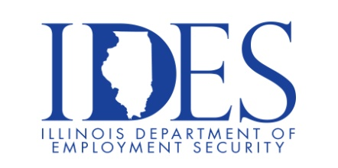

You are invited to Attend the WIOA Stakeholder Engagement Webinar for Job-Seekers

What: WIOA Stakeholder Engagement Webinar for Job-Seekers
When: Tuesday, October 10th, 2023 4:30 pm Central Time
This event is sponsored by WIOA and The Illinois Department of Employment Security

Illinois is developing a four-year plan for its workforce development system. The plan offers an opportunity to incorporate lessons learned over the past several years and new ideas that can help bolster our economy. This webinar is aimed specifically at job-seekers, workers, and their advocates. It will feature content that is unique to that audience, such as reducing barriers to services and increasing the availability of services in local communities. Participants will be invited to openly discuss concepts for addressing challenges and opportunities for improving the state’s workforce development system over the next four years.

Webinar Registration - Zoom

Make Sure Your Resume is on Illinoisjoblink.com
Illinois businesses are hiring. And they are looking for workers on Illinoisjoblink.com The state’s hiring board features more than 100,000 help-wanted ads. Job seekers can build multiple resumes to emphasize different skills and experiences. Business owners can use keyword matching technology to search resumes and find the best candidate. Illinoisjoblink.com is free for workers and employers. It compares favorably to private efforts that cost hundreds of dollars. No-cost HR recruitment services are available at the website and at (877) 342-7533.



Find a Job/Find an Employee

