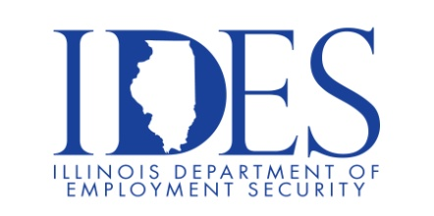

You are invited to Attend AECI SCHIRM USA Hiring Event
What: AECI SCHIRM USA Hiring Event When: Thursday, October 19, 2023 9:00 am– 1:00 pm Where: Man-Tra-Con Corporation 3117 Civic Circle Blvd. Marion, IL

This event is sponsored by AECI SCHIRM USA, Man-Tra-Con and the Illinois Department of Employment Security

Man-Tra-Con Corporation is hosting a hiring event for AECI Schirm USA for their manufacturing plant
in Benton, Illinois. Representatives from AECI Schirm will be present to answer questions and interview potential candidates. AECI Schirm USA is currently seeking candidates for the positions listed below.
Wages are $17.00 per hour, dependent upon experience:
Please bring a resume if you have one,
dress appropriately, and be prepared to interview

For complete job descriptions for the above positions, or visit:
http://www.mantracon.org/employment-opportunities

Make Sure Your Resume is on Illinoisjoblink.com
Illinois businesses are hiring. And they are looking for workers on Illinoisjoblink.com The state’s hiring board features more than 100,000 help-wanted ads. Job seekers can build multiple resumes to emphasize different skills and experiences. Business owners can use keyword matching technology to search resumes and find the best candidate. Illinoisjoblink.com is free for workers and employers. It compares favorably to private efforts that cost hundreds of dollars. No-cost HR recruitment services are available at the website and at (877) 342-7533.



Find a Job/Find an Employee

