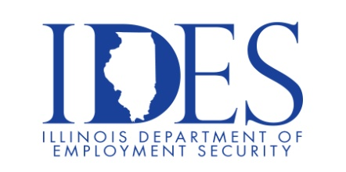

You are Invited to Attend the 3rd Annual National Disability Employment Awareness Month Workshop and Hiring Event

What: 3rd Annual National Disability Employment Awareness Month Workshop and Hiring Event
Community Partners share Self Employment & Other Career Opportunities
When: Wednesday, October 11, 2023 10:00 am - 12:00 pm
Where: Virtual Event
Please Register at: https://tinyurl.com/4vfejpxe

This event is sponsored by the Illinois Department of Human Services and the
Illinois Department of Employment Security

Make Sure Your Resume is on Illinoisjoblink.com
Illinois businesses are hiring. And they are looking for workers on Illinoisjoblink.com The state’s hiring board features more than 100,000 help-wanted ads. Job seekers can build multiple resumes to emphasize different skills and experiences. Business owners can use keyword matching technology to search resumes and find the best candidate. Illinoisjoblink.com is free for workers and employers. It compares favorably to private efforts that cost hundreds of dollars. No-cost HR recruitment services are available at the website and at (877) 342-7533.



Find a Job/Find an Employee

