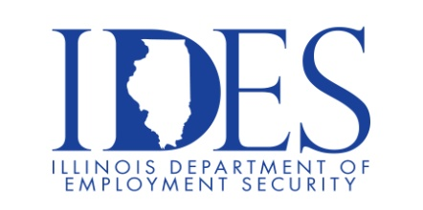

Illinois Department of Employment Security and Illinois Department of Corrections would like to invite you to a Corrections Officer & Corrections Treatment Officer Screening

What: Illinois Department of CORRECTIONS
Corrections Officer & Corrections Treatment Officer Screening
When: Monday December 4th, 2023
Time: Sign In 7:30am-8:30am
Please plan to be at the screening venue until at least 5:00pm.
Where: Kaskaskia College – Vandalia Education Center
2310 Fillmore Street
Vandalia, Illinois 62471

Contact Central Screening Office for invitation and paperwork. 217-785-9221

This event is sponsored by IDES and IDOC

Make Sure Your Resume is on Illinoisjoblink.com
Illinois businesses are hiring. And they are looking for workers on Illinoisjoblink.com The state’s hiring board features more than 100,000 help-wanted ads. Job seekers can build multiple resumes to emphasize different skills and experiences. Business owners can use keyword matching technology to search resumes and find the best candidate. Illinoisjoblink.com is free for workers and employers. It compares favorably to private efforts that cost hundreds of dollars. No-cost HR recruitment services are available at the website and at (877) 342-7533.



Find a Job/Find an Employee

