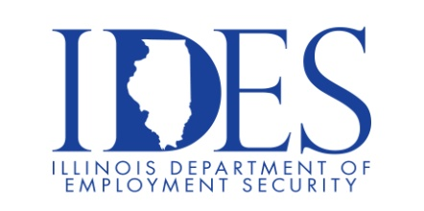

Scott AFB Area Veterans Job Fair

A RecruitMilitary Job Fair is an event where job seekers with military experience can meet with recruiters from local and national companies. These events are free for U.S veterans, military spouses, transitioning military, and members of the Guard and Reserve.

What: RecruitMilitary Scott AFB Area Veterans Hiring Event
When: Thursday, February 15, 2024 11:00 a.m. – 3:00 p.m.
Where: The Regency, 400 Regency Park, O'Fallon, IL 62269
Web Link: https://my.recruitmilitary.com/events/scott-air-force-base-area-veterans-job-fair-february-15-2024?utm_source=pardot&utm_medium=email&utm_campaign=ScottAFB_0224_influencer

RecruitMilitary's events are enhanced job fairs or career fairs with various types of exhibitors.

Employers
Franchisors
Educational institutions
Veterans' associations and service agencies
Government agencies

This event is sponsored by DAV and Recruit Military.

Make Sure Your Resume is on Illinoisjoblink.com
Illinois businesses are hiring. And they are looking for workers on Illinoisjoblink.com The state’s hiring board features more than 100,000 help-wanted ads. Job seekers can build multiple resumes to emphasize different skills and experiences. Business owners can use keyword matching technology to search resumes and find the best candidate. Illinoisjoblink.com is free for workers and employers. It compares favorably to private efforts that cost hundreds of dollars. No-cost HR recruitment services are available at the website and at (877) 342-7533.



Find a Job/Find an Employee

