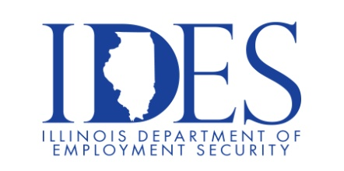

You are invited to the Department of Veteran Affairs and
Illinois Department of Employment Security
“Veteran Workshop - Federal Careers”

What: This workshop will provide you with information and assistance to help you obtain a great Federal Career!
When: Thursday February 27, 2024 12 PM – 4 PM
Where: 3117 Civic Cir Blvd Suite B (blue building across from Target)
Marion Il. 62959

We will guide you through the Federal hiring process!

1. Current USA Job listing
2. USA Job assistance
- Web site Assistance
- Information Format
- Paperwork required
- Qualifications
3. Resume Assistance
4. Interview Tips

This event is sponsored by IDES and The Dept. of Veterans Affairs.

Make Sure Your Resume is on Illinoisjoblink.com
Illinois businesses are hiring. And they are looking for workers on Illinoisjoblink.com The state’s hiring board features more than 100,000 help-wanted ads. Job seekers can build multiple resumes to emphasize different skills and experiences. Business owners can use keyword matching technology to search resumes and find the best candidate. Illinoisjoblink.com is free for workers and employers. It compares favorably to private efforts that cost hundreds of dollars. No-cost HR recruitment services are available at the website and at (877) 342-7533.



Find a Job/Find an Employee

