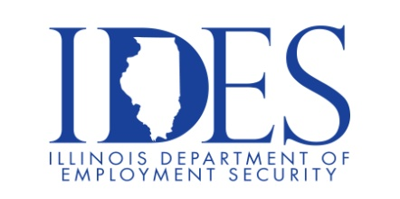

You are invited to the DCFS On-The-Spot Hiring Event!!

DCFS will highlight careers and the benefits of working for the State, breakdown the
application process and answer all questions regarding the hiring process.

What: DCFS On-The-Spot Hiring Fairview Heights
When: March 27th, 2024 10AM – 2PM
Where: Fountains Conference Center
319 Fountains Pkwy
Fairview Heights, IL 62208

DCFS is Seeking Qualified Candidates
Vacancies
Child Protection Specialist
Child Welfare Specialist
Child Protection Specialist, Opt SS
Child Welfare Specialist, Opt SS

Apply Directly: http://dcfsjobs.illinois.gov/ DCFS.Employment@illinois.gov www2.illinois.gov/DCFS

This event is sponsored by DCFS and IDES

Make Sure Your Resume is on Illinoisjoblink.com
Illinois businesses are hiring. And they are looking for workers on Illinoisjoblink.com The state’s hiring board features more than 100,000 help-wanted ads. Job seekers can build multiple resumes to emphasize different skills and experiences. Business owners can use keyword matching technology to search resumes and find the best candidate. Illinoisjoblink.com is free for workers and employers. It compares favorably to private efforts that cost hundreds of dollars. No-cost HR recruitment services are available at the website and at (877) 342-7533.



Find a Job/Find an Employee

