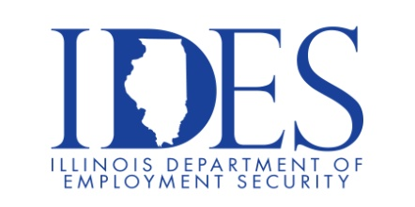

Are You Looking for a Job?

Your Illinois Department of Employment Security Invites You to a Job Fair

What: Lewis & Clark Community College Job Fair
When: Wednesday April 3rd 2024 9:00 a.m. – Noon
Where: Lewis & Clark Community College Job Fair – The Commons
5800 Godfrey Rd., Godfrey Illinois 62035

This event is sponsored by Lewis & Clark Community College and the Illinois Department of Employment Security

Dress appropriately Bring resumes Be prepared for interviews

In past years there were 125+ employers at this event

Business leaders want to know why they should hire you.
How will you make their company more successful?

Make Sure Your Resume is on Illinoisjoblink.com
Illinois businesses are hiring. And they are looking for workers on Illinoisjoblink.com The state’s hiring board features more than 100,000 help-wanted ads. Job seekers can build multiple resumes to emphasize different skills and experiences. Business owners can use keyword matching technology to search resumes and find the best candidate. Illinoisjoblink.com is free for workers and employers. It compares favorably to private efforts that cost hundreds of dollars. No-cost HR recruitment services are available at the website and at (877) 342-7533.



Find a Job/Find an Employee

