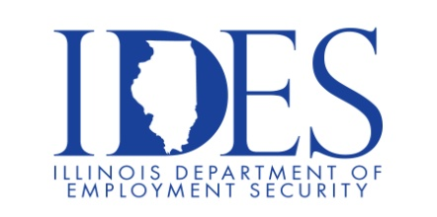
Is proud to partner with
Argosy Casino for a Job Fair! Tuesday, April 23rd from 10 am -2 pm.
for an On-Site Recruitment Event

Argosy Casino Offices
410 Piasa St
Alton Illinois 62002

NOW HIRING: Multiple Positions!

Business Casual Attire
Don’t miss the chance to meet the recruiters face-to-face.
Job offers on the spot!
THIS EVENT IS AT THE ARGOSY CASINO OFFICES AND NOT THE CASINO!

*Interested Candidates should bring proof of
availability to work in the US and your work history.

Make Sure Your Resume is on Illinoisjoblink.com
Illinois businesses are hiring. And they are looking for workers on Illinoisjoblink.com The state’s hiring board features more than 100,000 help-wanted ads. Job seekers can build multiple resumes to emphasize different skills and experiences. Business owners can use keyword matching technology to search resumes and find the best candidate. Illinoisjoblink.com is free for workers and employers. It compares favorably to private efforts that cost hundreds of dollars. No-cost HR recruitment services are available at the website and at (877) 342-7533.

Find a Job/Find an Employee

