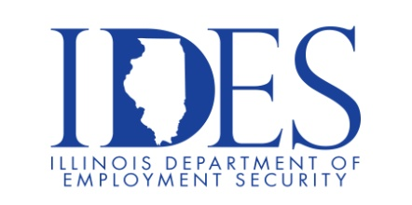

You are invited to Attend the
DCFS Virtual Employment Workshop

What: DCFS Virtual Employment Workshop
When: Thursday, June 6, 2024 11:00AM to 1:00PM
Where: This is a Virtual event using WebEx Platform
Register at: https://bit.ly/3tXoDVH

DCFS is seeking qualified candidates for the following positions:

Child Protection Specialist: Adams, Champaign, Coles, Cook, Kane,
Kankakee, Knox, LaSalle, Lake, McHenry, Macon, Macoupin, St. Clair,
Stephenson, Will, Winnebago
Child Welfare Specialist: Adams, Alexander, Champaign, Coles, Cook,
DuPage, Effingham, Fulton, Jefferson, Jersey, Knox, LaSalle, Lake, Logan,
McHenry, McLean, Macon, Madison, Massac, Peoria, Richland, Rock
Island, St. Clair, Sangamon, Union, Vermilion, Whiteside, Williamson,
Winnebago
Child Protection Specialist, Opt SS: Cook, Lake, McHenry,
Stephenson, Winnebago
Child Welfare Specialist, Opt SS: Cook, Winnebago
Office Associate, Opt 2: Throughout the State of Illinois

This event is sponsored by IDES and DCFS

Make Sure Your Resume is on Illinoisjoblink.com
Illinois businesses are hiring. And they are looking for workers on Illinoisjoblink.com The state’s hiring board features more than 100,000 help-wanted ads. Job seekers can build multiple resumes to emphasize different skills and experiences. Business owners can use keyword matching technology to search resumes and find the best candidate. Illinoisjoblink.com is free for workers and employers. It compares favorably to private efforts that cost hundreds of dollars. No-cost HR recruitment services are available at the website and at (877) 342-7533.



Find a Job/Find an Employee

