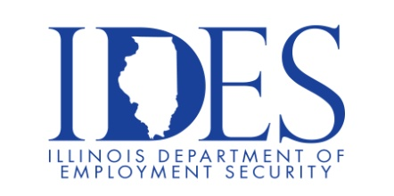

You are invited to the IDOT Career Fair!

IDOT will highlight careers and the benefits of working for the State, breakdown the
application process and answer all questions regarding the hiring process.

What: IDOT Career Fair
When: Thursday May 23rd, 2024, 10 AM - 3 PM
Where: SIUE E. St Louis Center
601 James R. Thompson Blvd
Building D
E St Louis Illinois 62201

See attachment for registration instructions.

This event is sponsored by IDOT, IDES, and State Representative Nikki Budzinski

Make Sure Your Resume is on Illinoisjoblink.com
Illinois businesses are hiring. And they are looking for workers on Illinoisjoblink.com The state’s hiring board features more than 100,000 help-wanted ads. Job seekers can build multiple resumes to emphasize different skills and experiences. Business owners can use keyword matching technology to search resumes and find the best candidate. Illinoisjoblink.com is free for workers and employers. It compares favorably to private efforts that cost hundreds of dollars. No-cost HR recruitment services are available at the website and at (877) 342-7533.



Find a Job/Find an Employee

