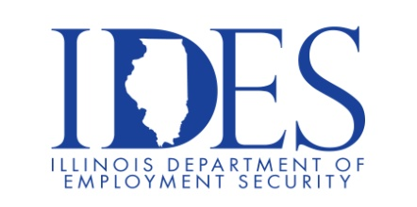

MARION SUMMER JOB FAIR!!!

The Illinois Department of Employment Security and Man-Tra-Con invite you to our Summer Job Fair with plenty of employers who have great job opportunities! Make the connection easily with employers who are ready to hire. Bring your resume and a great attitude and get that job you deserve!

What: Job Fair
When: July 16, 2024 9 AM to 1 PM
Where: The Pavillion, 1602 Sioux Dr., Marion, IL 62959

This event is sponsored by IDES and Man-Tra-Con.

Make Sure Your Resume is on Illinoisjoblink.com
Illinois businesses are hiring. And they are looking for workers on Illinoisjoblink.com The state’s hiring board features more than 100,000 help-wanted ads. Job seekers can build multiple resumes to emphasize different skills and experiences. Business owners can use keyword matching technology to search resumes and find the best candidate. Illinoisjoblink.com is free for workers and employers. It compares favorably to private efforts that cost hundreds of dollars. No-cost HR recruitment services are available at the website and at (877) 342-7533.



Find a Job/Find an Employee

