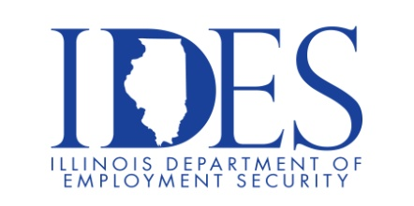

Are You Looking for a Job?

Your Illinois Department of Employment Security Invites You to Job Fair

What: Job Fair Hosted by District 114 State Representative Kevin Schmidt
When: Friday August 23rd 2024, 9:00 a.m. – 12:00 p.m.
Where: Wyvetter H. Young Higher Education Campus – Multipurpose Room – Bldg D
601 James R. Thompson Blvd
E. St. Louis, IL 62201

This event is sponsored by Kevin Schmidt, District 114 State Representative

Dress appropriately Bring resumes Be prepared for interviews.

Business leaders want to know why they should hire you.
How will you make their company more successful?

Make Sure Your Resume is on Illinoisjoblink.com
Illinois businesses are hiring. And they are looking for workers on Illinoisjoblink.com The state’s hiring board features more than 100,000 help-wanted ads. Job seekers can build multiple resumes to emphasize different skills and experiences. Business owners can use keyword matching technology to search resumes and find the best candidate. Illinoisjoblink.com is free for workers and employers. It compares favorably to private efforts that cost hundreds of dollars. No-cost HR recruitment services are available at the website and at (877) 342-7533.



Find a Job/Find an Employee

