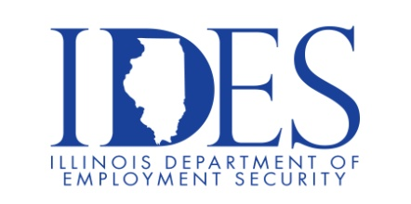
Want to work for the State of Illinois?

Don’t know where to start?

This Application Process Workshop is for you!

Your Illinois Department of Employment Security Invites You to a State Job Application Workshop
What: State of Illinois Department of Central Management Services
Application Process Workshop
When: 10:00 AM Tuesday, September 24th, 2024
Where: Americas Job Center
7650 Magna Dr
Ste 120
Belleville Illinois 62223

The State of Illinois is seeking candidates to fill multiple positions in multiple agencies. This hiring event provides employment opportunities, application criteria and hiring procedures.

- Department of Central Management Services (CMS) personnel will be here to speak on the hiring process and answer any questions.

- You must be registered and have an active resume in www.IllinoisJobLink.com!
- Please dress to impress and be prepared to listen and learn!

Make Sure Your Resume is on www.IllinoisJobLink.com

Illinois businesses are hiring. And they are looking for workers on Illinoisjoblink.com The state’s hiring board features more than 100,000 help-wanted ads. Job seekers can build multiple resumes to emphasize different skills and experiences. Business owners can use keyword matching technology to search resumes and find the best candidate. Illinoisjoblink.com is free for workers and employers. It compares favorably to private efforts that cost hundreds of dollars.
Find a Job/Find an Employee

