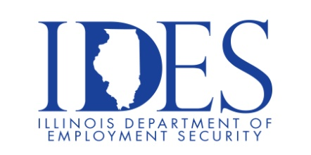

You are invited to the DCFS Virtual Recruitment Presentation!

DCFS will highlight careers and the benefits of working for the State, breakdown the
application process and answer all questions regarding the hiring process.

What: DCFS Virtual Recruitment Presentation
When: October 10th, 2024 11AM – 1PM
Where: This is a virtual event

Register at: https://bit.ly/470vixc

DCFS is Seeking Qualified Candidates
Vacancies/Counties
Child Protection Specialist: Adams, Champaign, Coles, Cook, Kane, Kankakee, Knox, LaSalle, Lake, McHenry, Macon, Macoupin, St. Clair, Stephenson, Will, Winnebago
Child Welfare Specialist: Adams, Alexander, Champaign, Coles, Cook, DuPage, Effingham, Fulton, Jefferson, Jersey, Knox, LaSalle, Lake, Logan, McHenry, McLean, Macon, Madison, Massac, Peoria, Richland, Rock Island, St. Clair, Sangamon, Union, Vermilion, Whiteside, Williamson, Winnebago
Child Protection Specialist, Opt SS: Cook, Lake, McHenry, Stephenson, Winnebago
Child Welfare Specialist, Opt SS: Cook, Winnebago Office Associate, Opt 2: Throughout the State of Illinois See a complete list of openings online.

Apply Directly: http://dcfsjobs.illinois.gov/ DCFS.Employment@illinois.gov www2.illinois.gov/DCFS

This event is sponsored by DCFS and IDES

Make Sure Your Resume is on Illinoisjoblink.com
Illinois businesses are hiring. And they are looking for workers on Illinoisjoblink.com The state’s hiring board features more than 100,000 help-wanted ads. Job seekers can build multiple resumes to emphasize different skills and experiences. Business owners can use keyword matching technology to search resumes and find the best candidate. Illinoisjoblink.com is free for workers and employers. It compares favorably to private efforts that cost hundreds of dollars. No-cost HR recruitment services are available at the website and at (877) 342-7533.



Find a Job/Find an Employee

