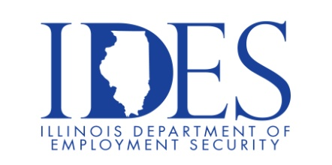

You are Invited to Attend the Wabash Valley College Career Fair

What: Wabash Valley College Career Fair
When: Friday, October 18, 2024 9:00 am - 1:00 pm
Where: Wabash Valley College
2200 College Drive
Mt. Carmel, IL

Illinois Eastern Community Colleges students and participating high schools will have the
opportunity to connect wih professionals, employers, and companies.

For more information, contact:
Cassandra Goldman goldman@iecc.edu or 618-262-8641 ext. 3510

This event is sponsored by Illinois Eastern Community Colleges, Wabash Valley College, Illinois Department of Commerce and Economic Opportunity and the
Illinois Department of Employment Security

Make Sure Your Resume is on Illinoisjoblink.com
Illinois businesses are hiring. And they are looking for workers on Illinoisjoblink.com The state’s hiring board features more than 100,000 help-wanted ads. Job seekers can build multiple resumes to emphasize different skills and experiences. Business owners can use keyword matching technology to search resumes and find the best candidate. Illinoisjoblink.com is free for workers and employers. It compares favorably to private efforts that cost hundreds of dollars. No-cost HR recruitment services are available at the website and at (877) 342-7533.



Find a Job/Find an Employee

