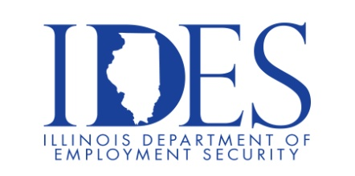
Are you a business owner, Payroll or Human Resources Professional?
This Employer Workshop is for you!

What: Employer Workshop
When: Thursday, October, 17, 2024 8:00 am – 4:00 pm
Where: Terry L. Bruce West Richland Center
320 East North Avenue
Noble, IL

Topics Covered:

Upcoming Legal Issues on the Horizon for 2025
Updates from Illinois Secure Choice
Illinois Department of Employment Security
Cyber Security and You
HR Panel Experts

This event is sponsored by Illinois Eastern Community Colleges and
The Illinois Department of Employment Security

Make Sure Your Resume is on Illinoisjoblink.com
Illinois businesses are hiring. And they are looking for workers on Illinoisjoblink.com The state’s hiring board features more than 100,000 help-wanted ads. Job seekers can build multiple resumes to emphasize different skills and experiences. Business owners can use keyword matching technology to search resumes and find the best candidate. Illinoisjoblink.com is free for workers and employers. It compares favorably to private efforts that cost hundreds of dollars. No-cost HR recruitment services are available at the website and at (877) 342-7533.



Find a Job/Find an Employee

