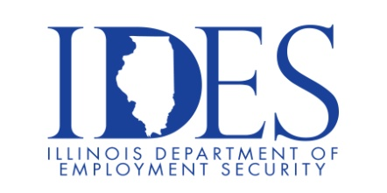

You are invited to Attend the Illinois Dept. of Human Services Choate Mental Health & Developmental Center Job Fair

IDHS will highlight careers and the benefits of working for the State, breakdown the
application process and answer all questions regarding the hiring process.

What: Choate Mental Health & Developmental Center Job Fair
When: Thursday, December 12 , 2:00 pm - 4:00 pm
Where: Choate Mental Health & Developmental Center
1000 North Main St.
Anna, IL

This event is sponsored by the Illinois Department of Human Services and Illinois Department of Employment Security

Make Sure Your Resume is on Illinoisjoblink.com
Illinois businesses are hiring. And they are looking for workers on Illinoisjoblink.com The state’s hiring board features more than 100,000 help-wanted ads. Job seekers can build multiple resumes to emphasize different skills and experiences. Business owners can use keyword matching technology to search resumes and find the best candidate. Illinoisjoblink.com is free for workers and employers. It compares favorably to private efforts that cost hundreds of dollars. No-cost HR recruitment services are available at the website and at (877) 342-7533.



Find a Job/Find an Employee

