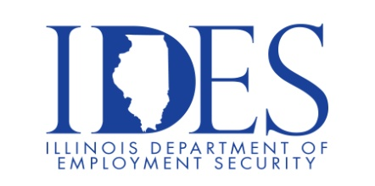

The Illinois Department of Employment Security Invites You to Attend the Urban League of Metropolitan Saint Louis Hiring Event
What: Urban League of Metropolitan Saint Louis Hiring Event
When: Thursday, November 21, 2024 10:00 am - 2:00 pm
Where: Clyde C. Jordan Senior Building
6755 State St.
East Saint Louis, IL

Over twenty Employers Ready to Hire

Please Dress for Suucess, Bring plenty of Resumes and be prepared for On the Spot Interviews

Business leaders want to know why they should hire you.
How will you make their company more successful?

Make Sure Your Resume is on Illinoisjoblink.com
Illinois businesses are hiring. And they are looking for workers on Illinoisjoblink.com The state’s hiring board features more than 100,000 help-wanted ads. Job seekers can build multiple resumes to emphasize different skills and experiences. Business owners can use keyword matching technology to search resumes and find the best candidate. Illinoisjoblink.com is free for workers and employers. It compares favorably to private efforts that cost hundreds of dollars. No-cost HR recruitment services are available at the website and at (877) 342-7533.

Find a Job/Find an Employee

