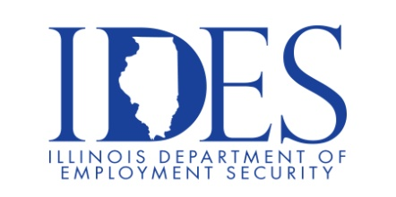

Looking for a Job! The Illinois Department of Employment Security Invites You to Attend the Effingham Job Fair!

What: Effingham Job Fair!
Where: Effingham VFW
2304 S Veterans Dr
Effingham, IL 62401
When: Tuesday, December 10, 2024 9:00 am -12:00 pm

This event is sponsored by Staff Quick, Pepsi and the Illinois Department of Employment
Security.

Make Sure Your Resume is on Illinoisjoblink.com
Illinois businesses are hiring. And they are looking for workers on Illinoisjoblink.com The state’s hiring board features more than 100,000 help-wanted ads. Job seekers can build multiple resumes to emphasize different skills and experiences. Business owners can use keyword matching technology to search resumes and find the best candidate. Illinoisjoblink.com is free for workers and employers. It compares favorably to private efforts that cost hundreds of dollars. No-cost HR recruitment services are available at the website and at (877) 342-7533.



Find a Job/Find an Employee

