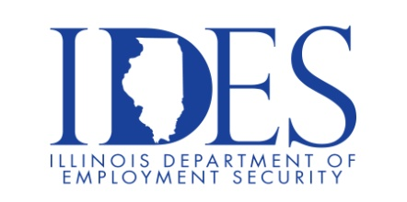

FCI GREENVILLE CAREER FAIR

What: Federal Bureau of Prisons - FCI Greenville Career Fair
When: Wednesday December 11, 2024 10:00 am – 6:00 pm
Where: 100 Highway 40, Greenville, IL 62246

FCI GREENVILLE is Hiring! Join us to learn about career opportunities available now across the institution.

We are offering up to a 19K Hiring Bonus- Direct Hire to newly hired employees! For more information visit FCI Greenville on December 11, 2024, and view USAJOBS.GOV.

This event is sponsored by IDES and FCI Greenville.

Make Sure Your Resume is on Illinoisjoblink.com
Illinois businesses are hiring. And they are looking for workers on Illinoisjoblink.com The state’s hiring board features more than 100,000 help-wanted ads. Job seekers can build multiple resumes to emphasize different skills and experiences. Business owners can use keyword matching technology to search resumes and find the best candidate. Illinoisjoblink.com is free for workers and employers. It compares favorably to private efforts that cost hundreds of dollars. No-cost HR recruitment services are available at the website and at (877) 342-7533.



Find a Job/Find an Employee

