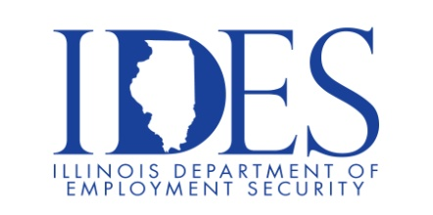

You are invited to the DAV Recruit Military Scott AFB Area Veterans Job Fair!

What: DAV Recruit Military Scott AFB Area Veterans Job Fair
When: Thursday February 13, 2025 11AM – 3PM
Where: The Regency, 400 Regency park, O'Fallon, IL 62269

Registration Link: https://rmvets.com/ScottAFBArea0225

Career Opportunities

Project Management | Human Resources | Transportation / Logistics | Healthcare Management / Supervision | Information Technology | Government & more…

This event sponsored by IDES and DAV Recruit Military.

Make Sure Your Resume is on Illinoisjoblink.com
Illinois businesses are hiring. And they are looking for workers on Illinoisjoblink.com The state’s hiring board features more than 100,000 help-wanted ads. Job seekers can build multiple resumes to emphasize different skills and experiences. Business owners can use keyword matching technology to search resumes and find the best candidate. Illinoisjoblink.com is free for workers and employers. It compares favorably to private efforts that cost hundreds of dollars. No-cost HR recruitment services are available at the website and at (877) 342-7533.



Find a Job/Find an Employee

