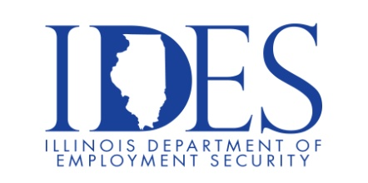

Take your career to the next level!
You are invited to attend Professional Career Development Workshops!

Get the information you NEED so that you can get the job you DESERVE!

What: Professional Career Development Workshops.

When: February 25, 2025 9AM – 11AM Resume Essentials / 11AM – 1PM Interview Skills

Where: The American Job Center, 7650 Magna Drive Suite #120, Belleville, IL 62223

Off Base Transition Training (OBTT) workshops are employment focused workshops for veterans, veterans currently serving in the National Guard and Reserve, and their spouses.

This event is sponsored by IDES and OBTT.

Make Sure Your Resume is on Illinoisjoblink.com
Illinois businesses are hiring. And they are looking for workers on Illinoisjoblink.com The state’s hiring board features more than 100,000 help-wanted ads. Job seekers can build multiple resumes to emphasize different skills and experiences. Business owners can use keyword matching technology to search resumes and find the best candidate. Illinoisjoblink.com is free for workers and employers. It compares favorably to private efforts that cost hundreds of dollars. No-cost HR recruitment services are available at the website and at (877) 342-7533.



Find a Job/Find an Employee

