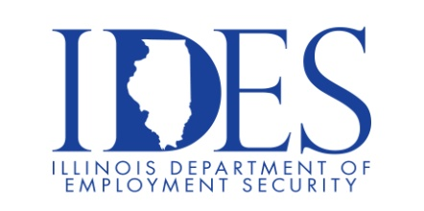

You are Invited to the Brookstone Estates of Effingham OPEN INTERVIEWS Event!

What: We have Certified Nursing Aide (CNA), Dietary Aide, and Cook opportunities available & would like to invite you to interview!
When: Friday, February 7, 2025 from 9am-11am & 1pm-3pm & 4pm-6pm | Walk-ins welcome
Where: Brookstone Estates of Effingham, 1101 N Maple St, Effingham, IL 62401

All qualified CNAs, Dietary Aides, and Cooks that successfully complete an interview will be entered in a raffle to win an Amazon gift card!
Complimentary refreshments will be provided. We look forward to meeting you!

If you are interested in interviewing, but unable to attend…
Please contact Nicole Ganz, Talent Acquisition Partner, at (815) 420-5909

This event is sponsored by Brookstone Estates of Effingham and the Illinois Department
of Employment Security

Make Sure Your Resume is on Illinoisjoblink.com
Illinois businesses are hiring. And they are looking for workers on Illinoisjoblink.com The state’s hiring board features more than 100,000 help-wanted ads. Job seekers can build multiple resumes to emphasize different skills and experiences. Business owners can use keyword matching technology to search resumes and find the best candidate. Illinoisjoblink.com is free for workers and employers. It compares favorably to private efforts that cost hundreds of dollars. No-cost HR recruitment services are available at the website and at (877) 342-7533.



Find a Job/Find an Employee

