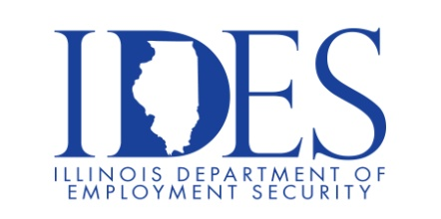

You are Invited to Attend the Pepsi Mid America Walk-In Wednesday Hiring Event

What: Pepsi Mid America Walk-In Wednesday Hiring Event
When: Wednesdays 9:00 am – 4:00 pm
Where: Pepsi Mid America
1400 West Jaycee Avenue
Effingham, IL

Exciting opportunities await you at our Effingham Depot. We are currently seeking dedicated individuals for the following positions:
- Merchandiser
- Route Sales (Paid training for non-CDL holders)
- Snack Route Sales (Paid training for non-CDL holders)

If you are dependable with a willingness to work and a desire to learn and grow, we want you on our team!

This event is sponsored by Pepsi Mid America and the Illinois Department of Employment
Security

Make Sure Your Resume is on Illinoisjoblink.com
Illinois businesses are hiring. And they are looking for workers on Illinoisjoblink.com The state’s hiring board features more than 100,000 help-wanted ads. Job seekers can build multiple resumes to emphasize different skills and experiences. Business owners can use keyword matching technology to search resumes and find the best candidate. Illinoisjoblink.com is free for workers and employers. It compares favorably to private efforts that cost hundreds of dollars. No-cost HR recruitment services are available at the website and at (877) 342-7533.



Find a Job/Find an Employee

