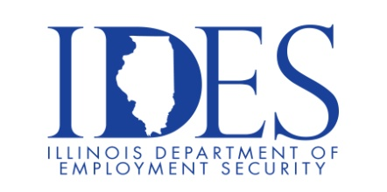

Veterans, Military Community Members and Family. The Illinois Department of Employment Security and Illinos Joining Forces Invites You to Attend the Southern Illinois Regional Summit!

What: Southern Illinois Regional Summit
Where: The Pavillion
1602 Sioux Dr.
Marion, IL 62959
When: Thursday, February 27th
Summit: 1 – 430 PM
Town Hall and Resource Fair: 5 – 8 PM

Make Sure Your Resume is on Illinoisjoblink.com
Illinois businesses are hiring. And they are looking for workers on Illinoisjoblink.com The state’s hiring board features more than 100,000 help-wanted ads. Job seekers can build multiple resumes to emphasize different skills and experiences. Business owners can use keyword matching technology to search resumes and find the best candidate. Illinoisjoblink.com is free for workers and employers. It compares favorably to private efforts that cost hundreds of dollars. No-cost HR recruitment services are available at the website and at (877) 342-7533.



Find a Job/Find an Employee

