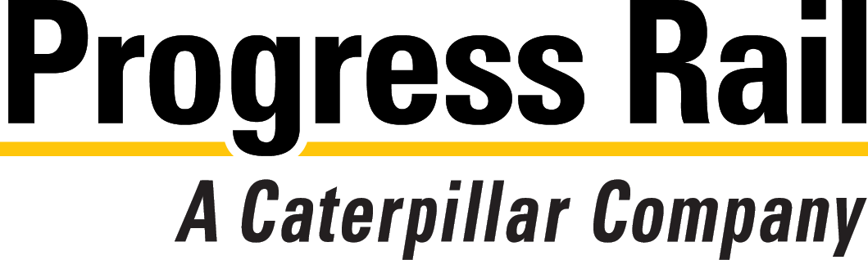

**3901 Missouri Ave. Alorton, IL 62207**

Hiring for Day and Afternoon Shifts – Monday through Friday.

General Laborers – Machine Operators – CNC Operators – Production Supervisor & Maintenance Mechanic (Afternoons)

**Open Interviews for All Positions March 3, 4, and 6th, 7:30a.m. to 4p.m.**

▼ **Join the Progress Rail Team** - m inspired by both history and innovation and an unmatched mix of products. We believe in investing in our people, both in hiring the best talent and helping them fulfill their ambitions and potential. Are you ready to take the next step?

If so, visit **www.progressrail.com/en/ Careers.html** to view available positions and complete your application.