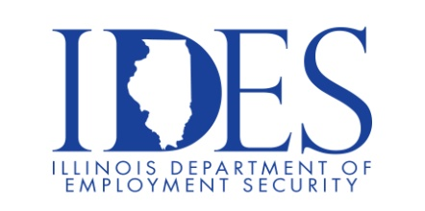
Are You Looking for a Job?

The Illinois Department of Employment Security and Pepsi MidAmerica Invite you to
Attend a Hiring Event

What: Pepsi MidAmerica Hiring Event
When: Tuesday, April 15, 2025, 10:00 am – 2:00 pm
Where: Illinois Department of Employment Security
333 Potomac Blvd
Mt. Vernon, IL

Now Hiring for the following positions
Store Reset Coordinator
Snack Route Sales
Route Sales – CDL - We will train for CDL!
Merchandiser

This event is sponsored by The Illinois Department Employment Security and
Pepsi MidAmerica

Business leaders want to know why they should hire you.
How will you make their company more successful?

Make Sure Your Resume is on Illinoisjoblink.com
Illinois businesses are hiring. And they are looking for workers on Illinoisjoblink.com The state’s hiring board features more than 100,000 help-wanted ads. Job seekers can build multiple resumes to emphasize different skills and experiences. Business owners can use keyword matching technology to search resumes and find the best candidate. Illinoisjoblink.com is free for workers and employers. It compares favorably to private efforts that cost hundreds of dollars. No-cost HR recruitment services are available at the website and at (877) 342-7533.

Find a Job/Find an Employee

