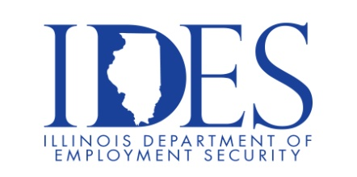

You are Invited to Attend the GDB International Open Interviews Wednesday

What: GDB International Open Interviews Wednesday
When: Wednesdays 1:00 pm – 4:00 pm
Where: GDB International
17396 Mockingbird Rd.
Nashville, IL

Please join us Wednesdays from 1:00 pm – 4:00 pm at GDB
International for Open Interviews Wednesday.

This event is sponsored by GDB International and the Illinois Department of
Employment Security

Make Sure Your Resume is on Illinoisjoblink.com
Illinois businesses are hiring. And they are looking for workers on Illinoisjoblink.com Job seekers can build multiple resumes to emphasize different skills and experiences. Business owners can use keyword matching technology to search resumes and find the best candidate. Illinoisjoblink.com is free for workers and employers. It compares favorably to private efforts that cost hundreds of dollars. No-cost HR recruitment services are available at the website and at (877) 342-7533.



Find a Job/Find an Employee

