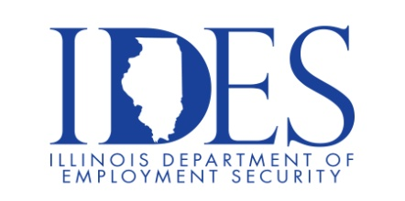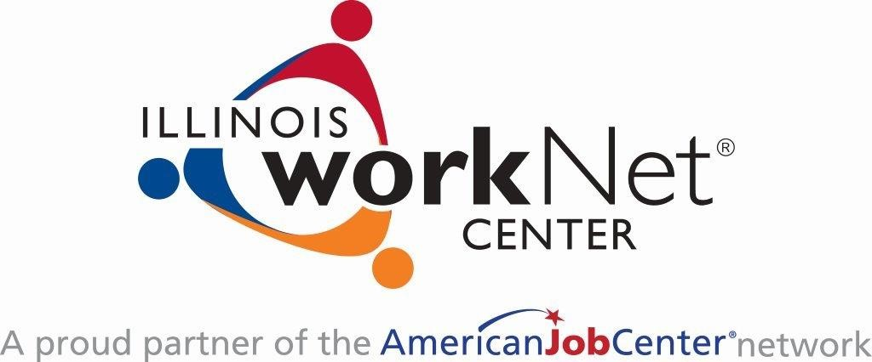

The Illinois Department of Employment Security Invites You to a State of Illinois Job Fair!

What: State of Illinois Job Fair
When: Friday, June 6, 2025 | 11:00 am – 3:00 pm
Where: Marion VFW | 201 East Longstreet Rd | Marion, IL

Multiple State Agencies will be participating in the event.
Please come prepared with a Resume

Make Sure Your Resume is up to date on IllinoisJobLink.com!
Illinois businesses are hiring and they are looking for workers on IllinoisJobLink.com. The state’s hiring board features thousands of open job postings. Job seekers can build multiple resumes to emphasize different skills and experiences. Business owners can search resumes and find the best candidate. IllinoisJobLink.com is free for jobseekers and employers. No-cost HR recruitment services are available at the website and at (877) 342-7533.


Find a Job/Find an Employee

