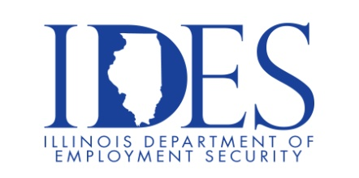

You are invited to Veterans’ Resource Fiar hosted by State Rep Katie Stuart, US Rep Nikki Bidzinski, and US Senator Tammy Duckworth!

Veteran Resource Fair
Saturday, June 28, 2025 10:00 am – 1:00 pm
American Legion Post 199
58 S State Route 157
Edwardsville, IL

This event will be attended by Illinois Department of Veteran Affairs, Illinois Department of Employment Security, State Attorney General’s Office, Got Your Six, Veteran Assistnace Commissions of St Claire & Madison County, Madison County Employment & Training, Illinois Joining Forces, and many more.

AdministratiMake Sure Your Resume is on Illinoisjoblink.com
Illinois businesses are hiring. And they are looking for workers on Illinoisjoblink.com. Job seekers can build multiple resumes to emphasize different skills and experiences. Business owners can use keyword matching technology to search resumes and find the best candidate. Illinoisjoblink.com is free for workers and employers. It compares favorably to private efforts that cost hundreds of dollars. No-cost HR recruitment services are available at the website and at (877) 342-7533.



Find a Job/Find an Employee

Looking to make a lasting impact in your community? The Illinois Department of Human Services offers rewarding career opportunities in various fields - Business, Management and Administration, Medicine and , Healthcare, Community and Social Services, Technology,

