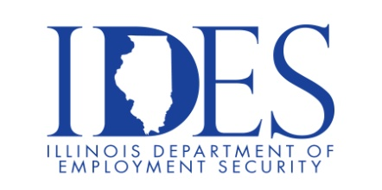

Military Community Hiring Event

A Recruit Military Job Fair is an event where job seekers with military experience can meet with recruiters from local and national companies. These events are free for U.S veterans, military spouses, transitioning military, and members of the Guard and Reserve.

What: Recruit Military: Military Community Hiring Event
When: Thursday, July 24, 2025 11:00 a.m. – 3:00 p.m.
Where: Chaifetz Arena | 1 South Compton Avenue, St. Louis, MO 63103
Web Link: https://rmvets.com/STL0725

Career Opportunities

Project Management / Human Resources / Transportation / Logistics / Healthcare / Management & Supervision / Information Technology / Government & more....

This event is sponsored by Recruit Military.

Make Sure Your Resume is on Illinoisjoblink.com
Illinois businesses are hiring. And they are looking for workers on Illinoisjoblink.com The state’s hiring board features more than 100,000 help-wanted ads. Job seekers can build multiple resumes to emphasize different skills and experiences. Business owners can use keyword matching technology to search resumes and find the best candidate. Illinoisjoblink.com is free for workers and employers. It compares favorably to private efforts that cost hundreds of dollars. No-cost HR recruitment services are available at the website and at (877) 342-7533.



Find a Job/Find an Employee

