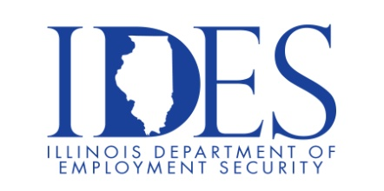

You are invited to Draft Kings at Casino Queen Direct Hiring Event!

What: Draft Kings Direct Hiring event.

When: June 30, 2025 9:00 AM – 12:00 PM

Where: The American Job Center, 7650 Magna Drive Suite #120, Belleville, IL 62223

Current Openings: Cooks; Cashier Attendant; Busser; Dishwasher; Porter; Dealer; Floor Supervisor; Cage Cashier; Casino Host; Marketing Coordinator; Maintenance; Engineer; Laborer; Slot Technician; Front Desk Clerk; Night Auditor; Security Officer.

See the full list at:
https://draftkingsatcasinoqueen.com/careers/

This event is sponsored by IDES and Draft Kings at Casino Queen.

Make Sure Your Resume is on Illinoisjoblink.com
Illinois businesses are hiring. And they are looking for workers on Illinoisjoblink.com. Job seekers can build multiple resumes to emphasize different skills and experiences. Business owners can use keyword matching technology to search resumes and find the best candidate. Illinoisjoblink.com is free for workers and employers. It compares favorably to private efforts that cost hundreds of dollars. No-cost HR recruitment services are available at the website and at (877) 342-7533.



Find a Job/Find an Employee

