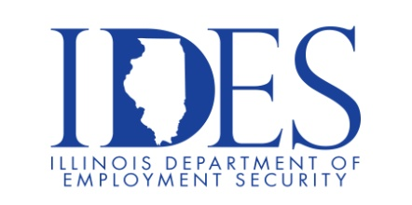

Collinsville Unit 10 Non-Certified Job Fair

What: Collinsville Unit 10 Job Fair
When: Thursday July 24th, 9:30 a.m. – 4:00 p.m. EST
Where: 123 W. Clay St., Collinsville, IL 62234

Join our Administration team any time between 9:30am and 4:00pm.
No appointment is necessary to attend.
First Student [Bus Company] and Sodexo [Food Service] will be in attendance. Candidates being recommended for employment
will be sent for a background check and fingerprinting.

You can apply online now through the Employment Opportunities link on www.kahoks.org. Any questions can be emailed to krobinso@cusd.kahoks.org

Employment is set to begin on August 11, 2025

This event is sponsored by IDES and the Collinsville Unit 10.

Make Sure Your Resume is on Illinoisjoblink.com
Illinois businesses are hiring. And they are looking for workers on Illinoisjoblink.com The state’s hiring board features more than 100,000 help-wanted ads. Job seekers can build multiple resumes to emphasize different skills and experiences. Business owners can use keyword matching technology to search resumes and find the best candidate. Illinoisjoblink.com is free for workers and employers. It compares favorably to private efforts that cost hundreds of dollars. No-cost HR recruitment services are available at the website and at (877) 342-7533.



Find a Job/Find an Employee

