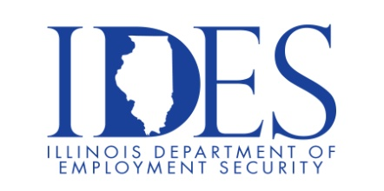

You are invited to the Aerospace Industry Career Fair!

What: Career Fair
When: August 14, 2025 10 AM – 3 PM
Where: The Regency, 400 Regency Park, O’Fallon, IL 62269

- Meet with recruiters from 25 companies.
- Discover job openings across diverse industries.
- Resume reviews by experts.
- Industry leader insights.
- Networking opportunity.

This event is sponsored by Leadership Council Southern Illinois and Scott Military and Family Readiness Center.

Make Sure Your Resume is on Illinoisjoblink.com
Illinois businesses are hiring. And they are looking for workers on Illinoisjoblink.com The state’s hiring board features more than 100,000 help-wanted ads. Job seekers can build multiple resumes to emphasize different skills and experiences. Business owners can use keyword matching technology to search resumes and find the best candidate. Illinoisjoblink.com is free for workers and employers. It compares favorably to private efforts that cost hundreds of dollars. No-cost HR recruitment services are available at the website and at (877) 342-7533.



Find a Job/Find an Employee

