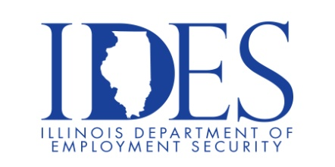

You are Invited to Attend the IDES and Charleston Carnegie Public Library Job Fair

What: Job Fair
When: Thursday, Aug 21st 1030AM-130PM
Where: Charleston Carnegie Public Library
6th St & Van Buren Ave.
Charleston, IL 61920

This event is sponsored by the Illinois Department of Employment Security and the Charleston Public Library.

Make Sure Your Resume is on Illinoisjoblink.com
Illinois businesses are hiring. And they are looking for workers on Illinoisjoblink.com The state’s hiring board features more than 100,000 help-wanted ads. Job seekers can build multiple resumes to emphasize different skills and experiences. Business owners can use keyword matching technology to search resumes and find the best candidate. Illinoisjoblink.com is free for workers and employers. It compares favorably to private efforts that cost hundreds of dollars. No-cost HR recruitment services are available at the website and at (877) 342-7533.



Find a Job/Find an Employee

