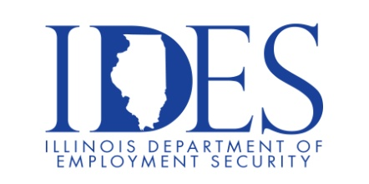

You are Invited to Attend Senator Erica Harriss and Representative Amy Elik's Job Fair

Senator Erica Harriss and Representative Amy Elik's Job Fair
Friday, September 5, 2025, 9:00 AM -1:00 PM
Lewis and Clark Scott Bibb Center
1004 East 5th Street
Alton, IL

Meet 30+ Employers & Organizations

Engage with Local and State Agencies

Connect with Hiring Managers

Explore Career Opportunities

Make Sure Your Resume is on Illinoisjoblink.com
Illinois businesses are hiring. And they are looking for workers on Illinoisjoblink.com Business owners can use keyword matching technology to search resumes and find the best candidate. Illinoisjoblink.com is free for workers and employers. It compares favorably to private efforts that cost hundreds of dollars. No-cost HR recruitment services are available at the website and at (877) 342-7533.



Find a Job/Find an Employee

